**JRM Sacco Management System MVP Specification**

**Architecture**

Web Browser

https://xxxx.com

DNS

Check IP address of JRM based on name

(New user)

Return IP Address

Load Balancer (HAProxy) / Proxy Server (E.g., Cloudflare)

Web Server

(Nginx/Apache)

Application Server

Static &

Dynamic Pages

Codebase

Database

Cache

Secure Connection (SSL)

SSL

**Data Modelling**

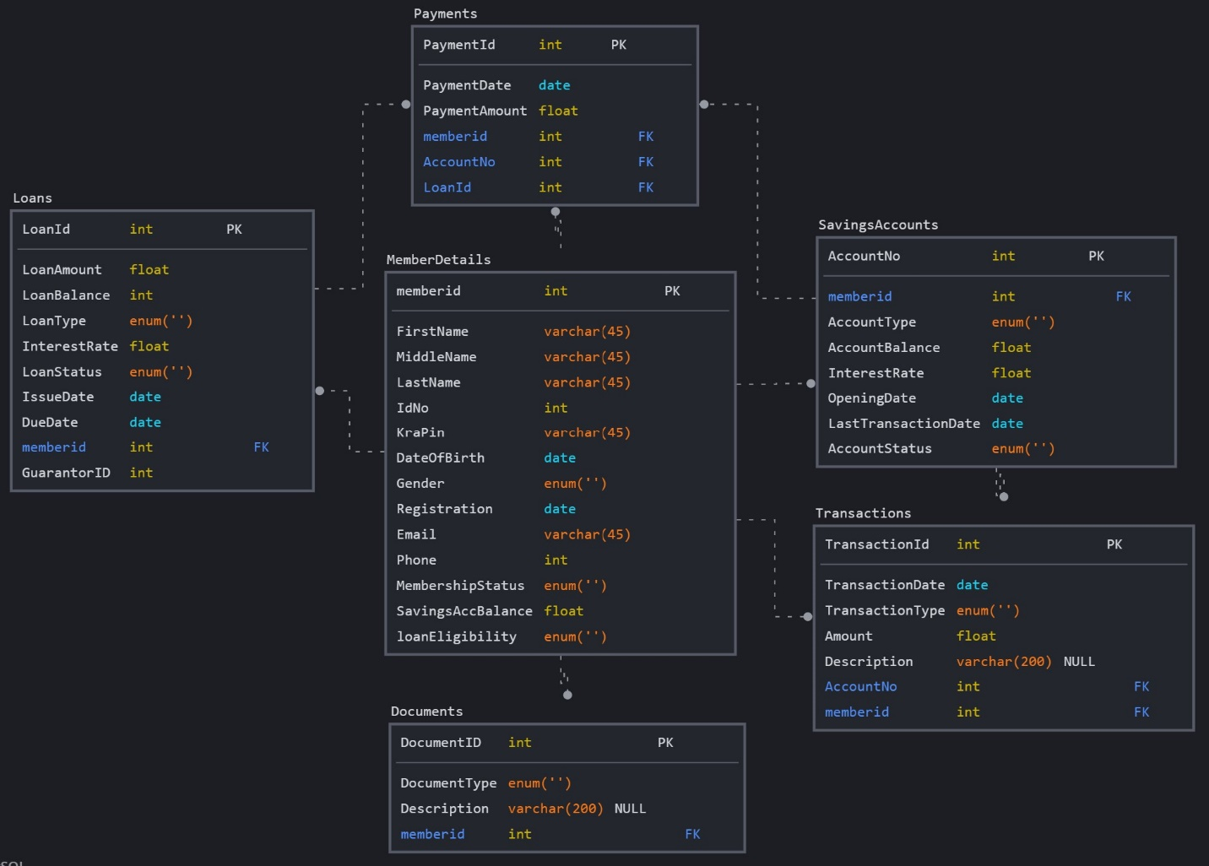

**User Stories**

1. **Member Registration:**
   * As a SACCO manager, I want to register new members with their personal details (name, contact information, address) so that they can become part of the SACCO community.
   * Acceptance Criteria:
     + Capture and store member's basic information.
     + Generate a unique member ID for each registration.
     + Ensure data validation for accurate information.
2. **Savings Account Management:**
   * As a SACCO member, I want to open a savings account and make deposits to it, so that I can save money and earn interest.
   * Acceptance Criteria:
     + Members can open new savings accounts.
     + Members can deposit money into their accounts.
     + Calculate and display current account balance.
     + Accurate interest calculations are applied to savings.
3. **Loan Application and Approval:**
   * As a SACCO member, I want to apply for a loan, have it reviewed, and approved so that I can access funds for various purposes.
   * Acceptance Criteria:
     + Members can submit loan applications.
     + Loan applications are reviewed by designated personnel.
     + Automated eligibility checks based on predefined criteria.
     + Generate loan approval notifications and terms.
4. **Loan Repayment and Tracking:**
   * As a SACCO member with an active loan, I want to make regular loan repayments and track my outstanding balance.
   * Acceptance Criteria:
     + Members can view their loan details and repayment schedule.
     + Members can make loan repayments through various payment methods.
     + Update loan balance and interest calculations after each repayment.
     + Display the remaining balance and next installment due date.
5. **Reports and Analytics:**
   * As a SACCO manager, I want to generate reports and view analytics to monitor the financial health of the SACCO and its members.
   * Acceptance Criteria:
     + Generate member account statements showing transactions and balances.
     + Generate loan repayment schedules and history.
     + Provide insights into popular loan products, savings trends, and defaults.
     + Display key financial metrics, such as total assets, liabilities, and net worth.